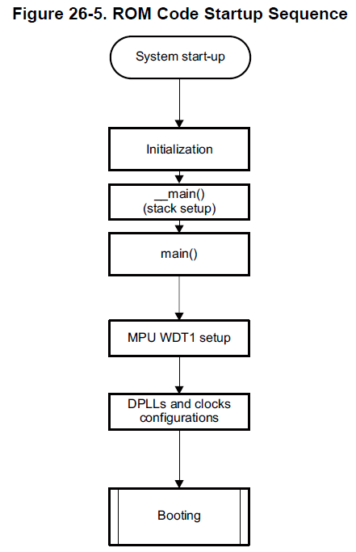

Fig: the booting operation RBL in SOC

second process in boot loader(SPL/second stage program loader):
Memory:
a) the Soc have 176KB of ROM.
b) ROM size id 128KB(64 in+64 out).

When u give power to SOC,it goes to power on reset in SOC
SOC
Power on reset

Power + & -
Soc goes this
and rom boot loader(RBL ) is the first software component run in SOC.

The rom code initialization goes on below sequence

Second action
First action

Watch dog timer initialized On every 3min
If RBL Not loaded second stage boot loader(SPL) with in 3min in it will be
Reset the processer automatically.

DPLL and clock Configuration is very importent initialization.

PLL stands for phase lock loop. It is clock generating engin for wide range of clocks sub systems of the SOC .

The operation of PLL is shown below.

output
PLL
24Mhz cristal
Upto 800Mhz
input

Fig: when i give low frequency PLL give higher frequency

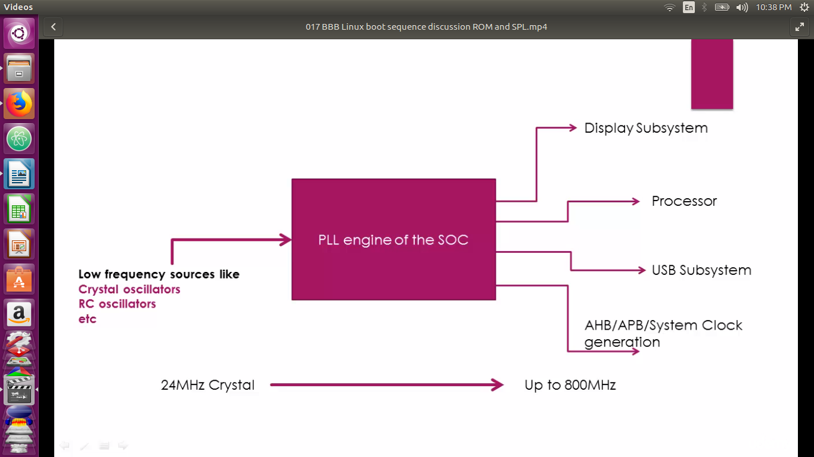
the generating frequency is helpfull to Display unit , processer ,usb subsystems and system clock generations and etc.

During clock initialization what rom boot loader do?

It checks sysboot [15:14] means 14 and 15 bits of sysboot registry , the RBL comes to know about the value of the external crystal connectioned to the SOC.

15: 14 bits mode | Crystal frequency
00 | 19.2 MHZ
01 | 24MHZ
10 | 25MHZ
11 | 26MHZ
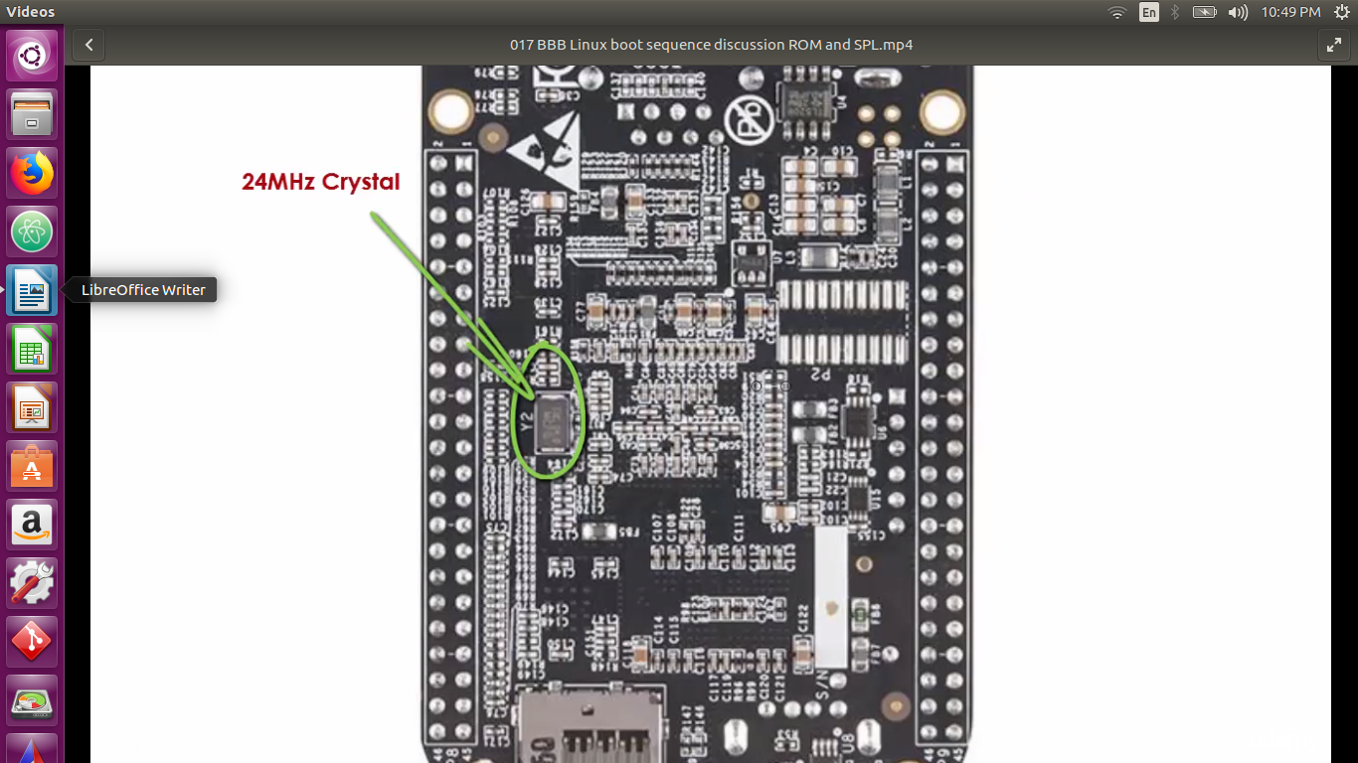
Fig: find theh crystal occeilater.
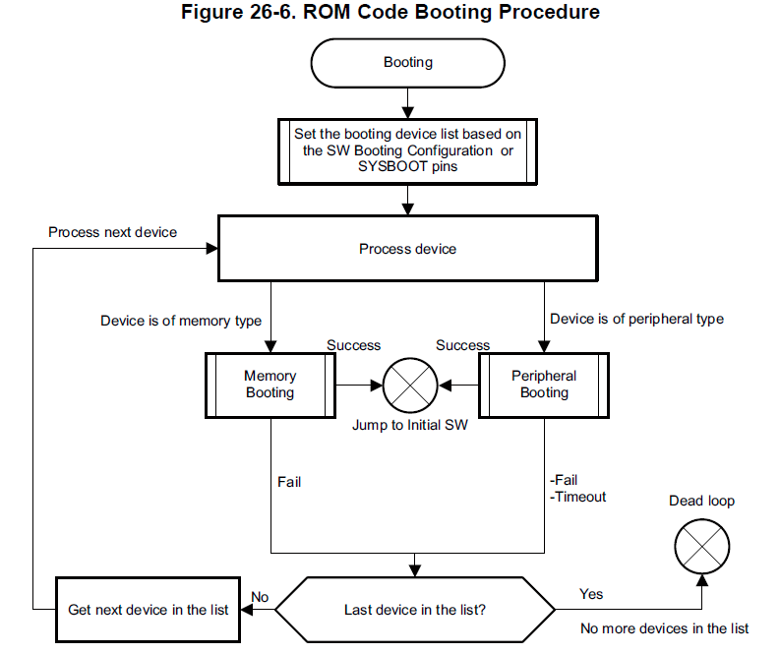
After that the RBL goes to booting here means now it wants load second stage boot loader(SPL) found in external memory or peripherals. It will goes to all boot list and loop is exit if a valid booting image is found and executed or watch dog expiration.

It finds the second stage boot loader on the EMMC memory of the board.
Emmc is Embedded multi-media memory controler and it refers to a package consisting of both
memory and flash memory controller integrated on the same silicon die.

The ROM cort in SOC copy images from SPL to internal RAM.

11/16/2018
The RBL reads first reads the first image header of MLO .from image header it will get important an information.
- Load the address.
- Total size of MLO.
MPL
Image header
SPL
Load _addr=0x40000000

So RBL load the MLO to the internal Ram address indicated by image headerof the MLO.

Summary : RBL
- Stack Setup
- Watchdog timer 1 configuration (set to 3 minutes timeout).
- System clock configuration using PLL.
- Search memory devices or other bootable interfaces for MLO or SPL.
- Copy “MLO or SPL” in to the internal SRAM of the chip.
- Execute MLO or SPL.
MLO/SPL JOB
MLO or SPL initialize the SOC to point that U-boot can be loaded into external RAM (DDR memory).for a project you want to know proper clock frequency according to that reconfigure the PLL.
1.it does UART console initialization to print out the debug messages.
2.Reconfigures the PLL to desired value.
3.initialize the DDR register to use the DDR memory.
4.Does muxing configuration of boot peripherals pin,because its next job is to
load the u-boot from the boot peripherals.
5.eg. If MLO is going to get the U-boot from the MMC0 and MMC1 interference, then it will do mux configuration to bring out the MMC0 and MMC1 functionalities on the pins.
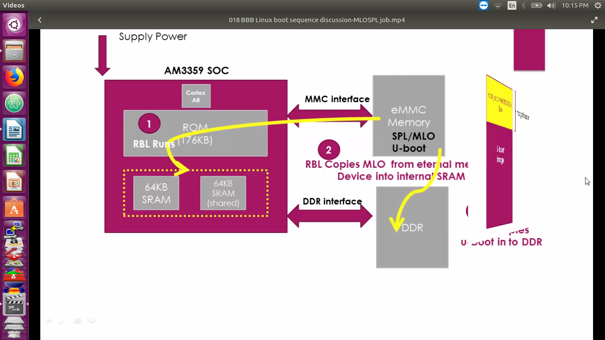
6.copy the U-boot image into the DDR memory and pass control to it.
And U-boot also have its won image header it will be indicates to load address and the size of the image to follow .So the MLO loads the U-boots to the address as indicated by the U-boot image header .MLO is not load the third stage boot loader like U-boot to the internal RAM of the SOC why? Because of the internal RAM is only 128KB.So U-boot is not fit for that .It copys to DDR.

Can we avoid using MLO or SPL by making RBL directly loads the U-boot in to internal SRAM ?
ANS: the Size of the internal RAM is 128 KB out of that 1mB is considered as secured memory which cannot used and also some space is reserved for Stack and heap relative activites.So the avilable space <=128KB
avilable space <=128KB
STAck& heap
Security

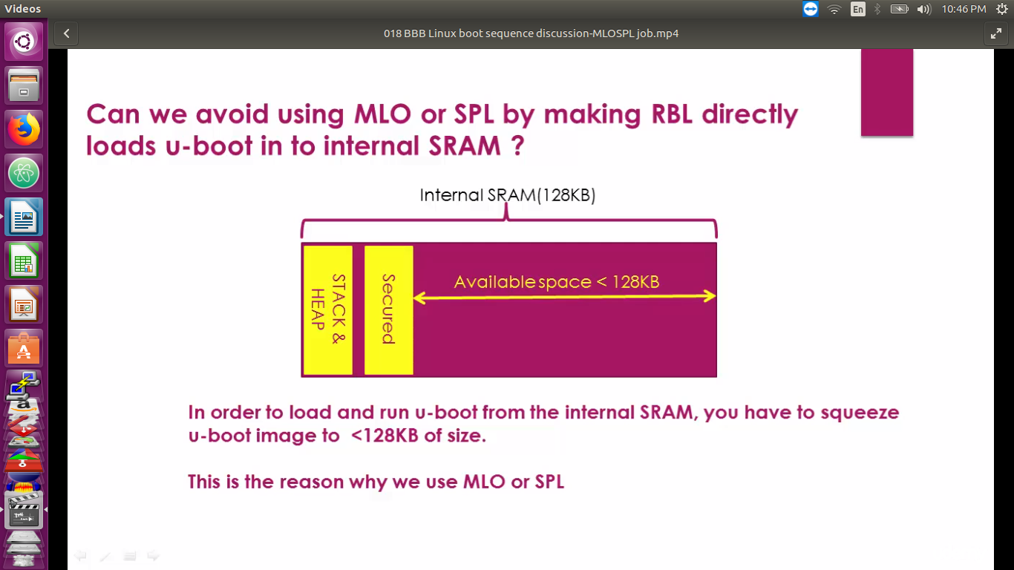

Real world Examples in booting of the Beagalbone Black linux Board
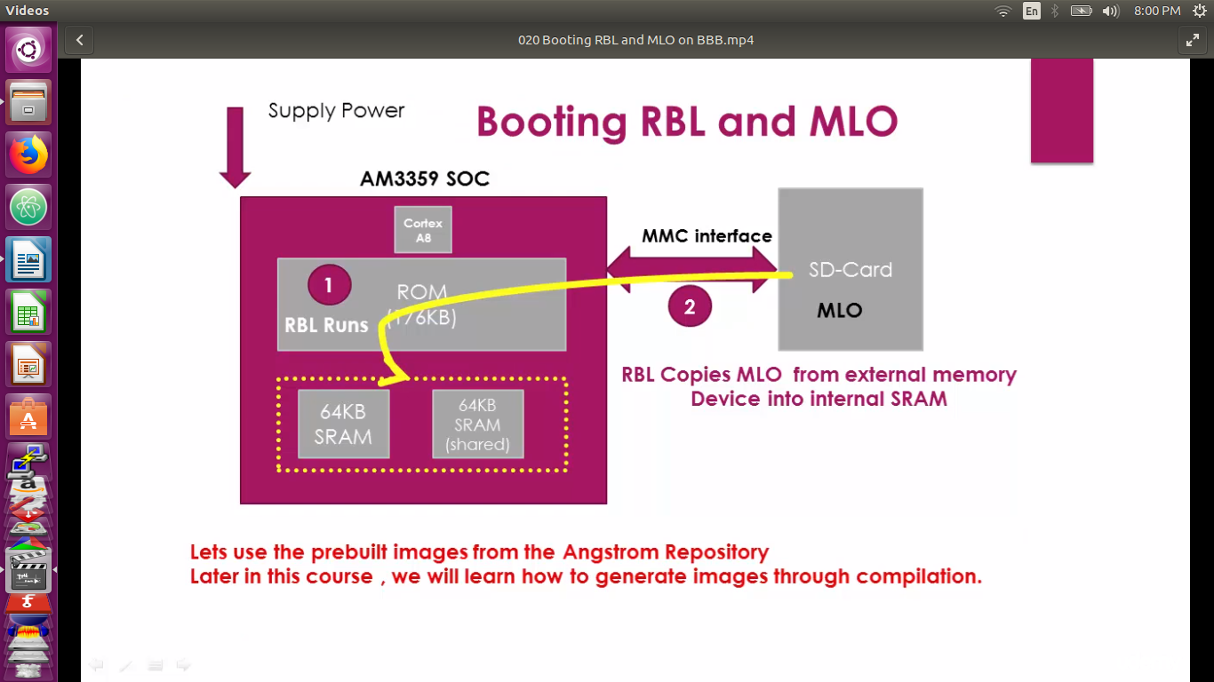
just type Angstrom begalbone black demo image. And open the repositary link was show below.
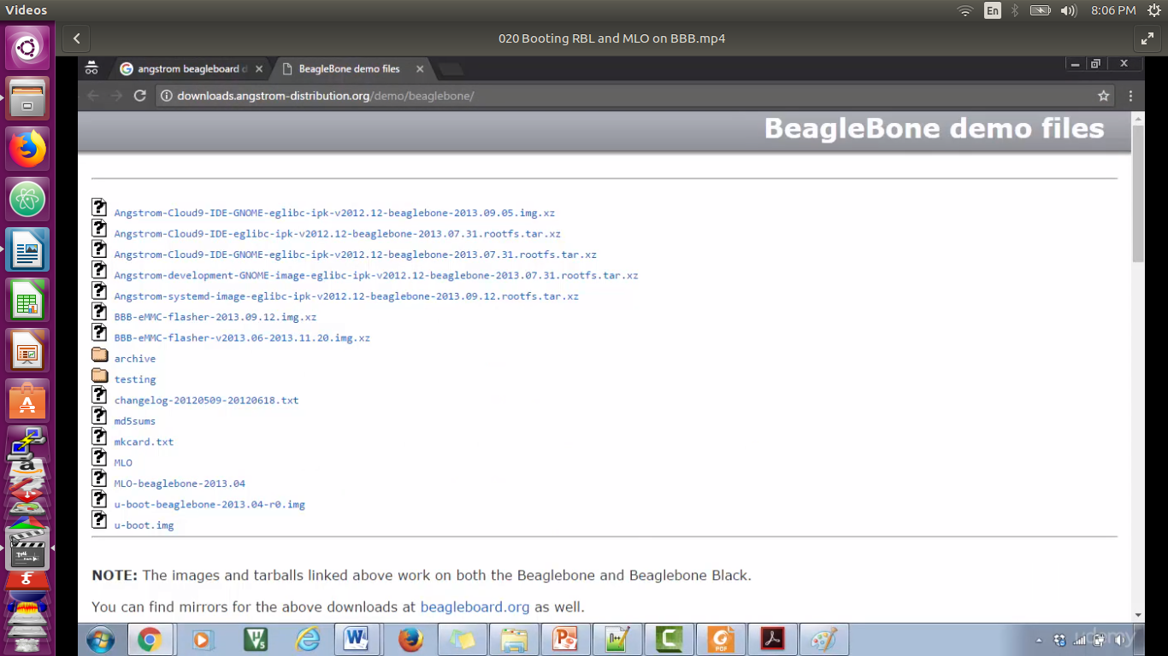
These all are the prebulded images to boot the linux kernal images succesfully on begal bone black. Now download MLO Begalbone from the above link. And save this file in custom location.
Now boot begalbone using SD card .before booting u need to follow some steps .
1.partition the SD card into two parts.
Partition 1
Boot and
FAT( this partition holds the
Boot image )
Partition 2
(this partiotion will hold the root file system)
(EXT3/EXT4)

Now inset SD in begalbone and also connect the begalbone to system.

1.Open terminal using ctrl+alt +t now terminal is opened .enter dmesg
2.now you get sdb details in terminal.
3.download and install Gparted software and open this software.
4.select the SD card in Gparted.
5.selct the memory card--->right click ->Delete->
actually it is not deleted untill u apply button in Gparted.
6.selct the memory card--->right click ->new.
Here u r select file system : fat 16
lable : BOOT

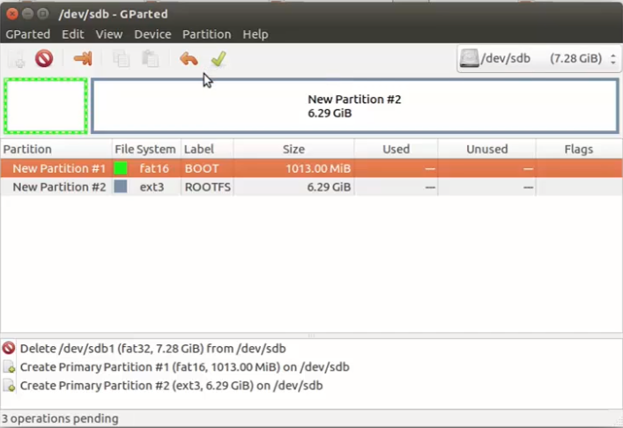
fig: memory partition in SD card

and select the space/memory for boot relative files. Add to SD and similarly create new meory space for Ext4 and label as ROOT for root file system.

Note:apply the changes.

You have set some the flags for boot partion for that:
Right click on boot partion and selct Manage flags->boot->close

Now the Boot partition is represent as Boot flage in that partition boot block and now we will copy MLO in to the boot partion which we just created. For thar MLO we aready downloaded from above link.

For that copy go to the terminal and use commnd in side of download folder then use
$ cp MLO-begalebone-2013.04 /media/kiran/BOOT/MLO,
let take out SD card and check it booting or not.

Connect your BBB to PC using USB_UART cable or H/W also connnect BBB to PC Mini USB cable.

Now open minicom in your terminal using $ sudo minicom .check below steps
connect SD card to the SD card slot of the BBB.press and hold the s2 button(boot button)
press the S3 button(power button)
release the s2 button.

We are booting only MLO only not U-boot/spl.

Testing U-boot in SD card:
now download same website above ,download U-boot beagalbone 2013.04.r0.img and copy same as above MLO
$ cp u-boot beagalbone 2013.04.r0.img /media/kiran/BOOT/Uboot.img
now remove SD card and attach SD to BBB and press s2 ,S3 button same as above. Now BBB is boot upto U-boot. It load all the boot related operation exept os because it did not find any linux image because they is noo linux image attached now.

BBB linux boot sequence discussion:

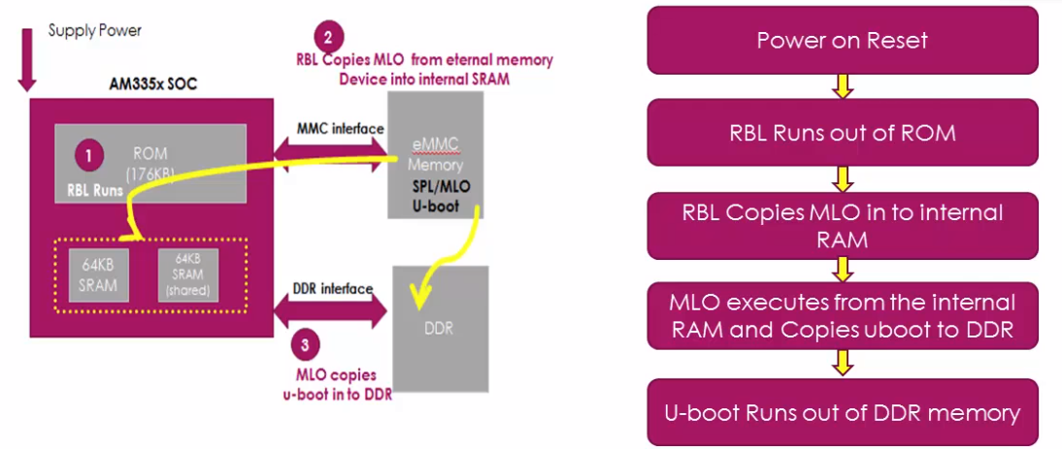
job of U-boot:
the MLO loads u-boot from external memory from peripheral DDR interface to the board shown above fig.conce image loads into the DDR triggers the execution for U-boot and U-boot performs many hardware relative initialize some of the peripherals like I2C,NAND ,Flash,ethernet,UART<USB,MMC,etc,because it supports loading kernal from all the peripherals.

Load the linux kernal image form various boot sources to the DDR memory of the board.

Boot sources : USB,eMMC,SD card, Serial Port,NAND flash ,etc.

Passing of boot arguments too the kernal.

Now u can provide a txt file ,you can change the boot behavior of the U-boor behavior of the u-boot by using a file called uEnv.txt. Use this file to set the env variables which drives the uboot according to need.

BBB Linux boot sequence discussion-uboot :
U-BOOT is always look as U-Image.
U-image is combination of Zimage(ELF format of binary file of linux kernal) + U-boot image header.
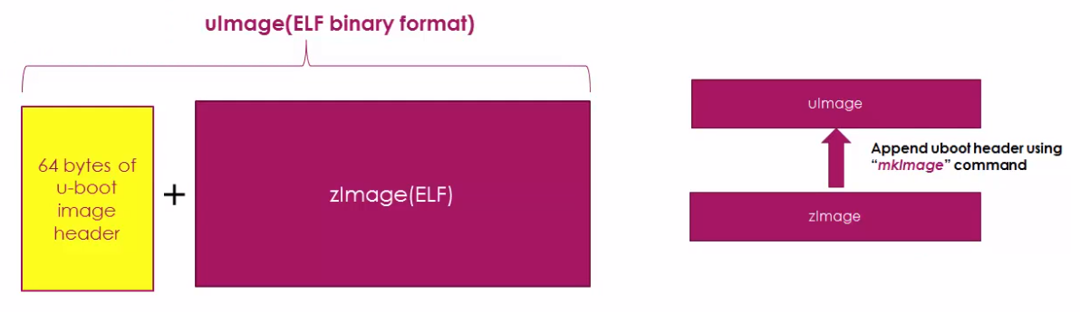
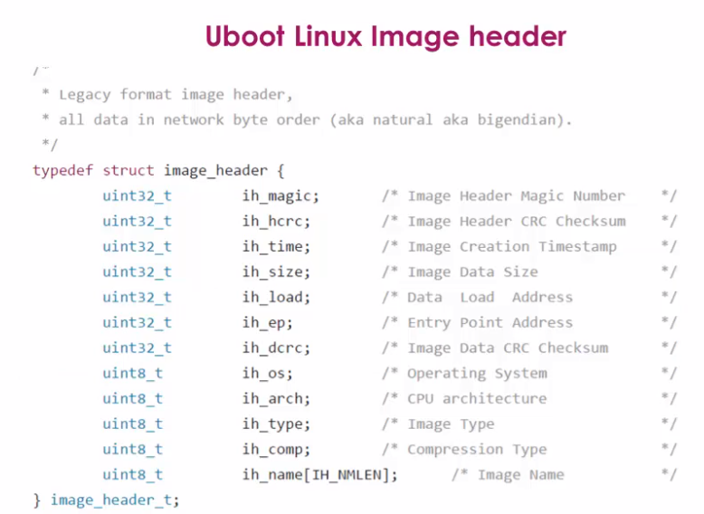
Fig : header of image

So we find the Linux kernal in Angstron-system-image-elibc-ipk-v2012.12-beglebone-2013.09.12-rootfs.tar.xz under this tar file we get the linux kernal.

Extract the above file in current folder, open boot folder under the boot folder we observe the all kernal images here. Now the all extracted file were copy into the rootfs partition of the SD card.

$ cp -r * /media/kiran/rootfs
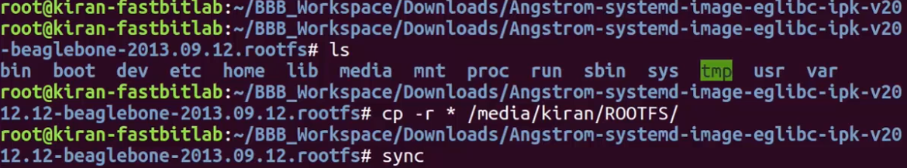
U-boot is supose to load the linux kernal ,but U-boot has no idia where is the linux kernal is reciding in SD card.that why we use uEnv.txt file to tell the where is linux kernal.

Now create a uEnv.txt file in boot block and open it and add some text.the contant of this code is shown in next videos.Now unmount SD and placed in BBB and start it.Now check all boot logs in terminal.

Decoding U-boot Header of uImage Manually

U image is U-boot frendlt image because it contains U-boot header image on top of thte G-image and when U-boot is try to load U-image it actualy ffetch the header info and display on console.

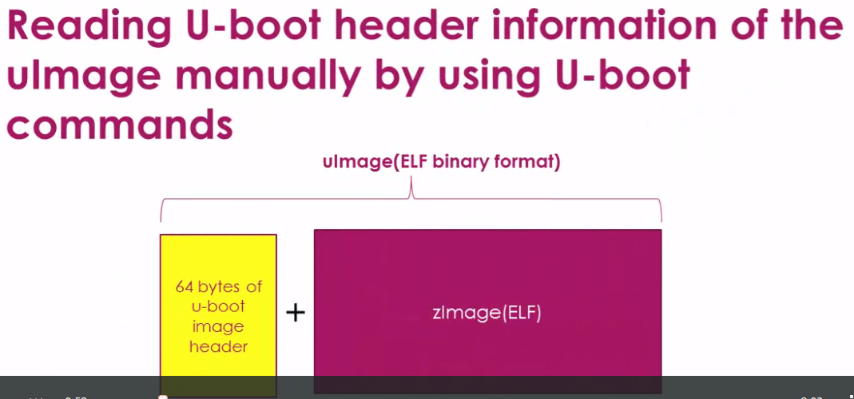
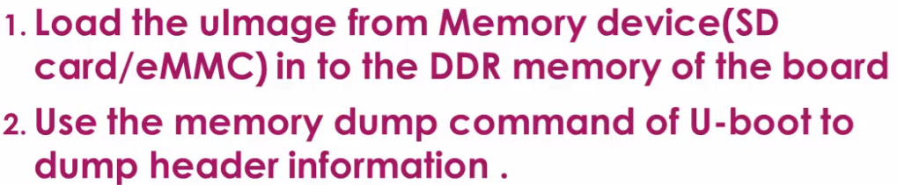

Now give on terareminal with commands as load .
Use load MMC0 it’s for load from micro SD card and MMC1 is EMMC interface.
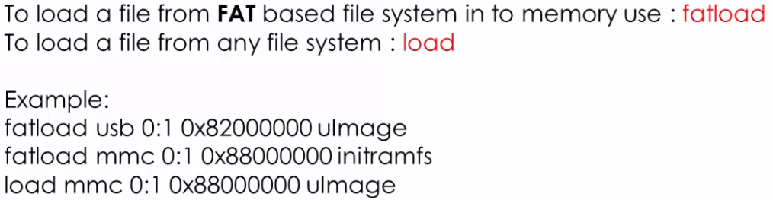
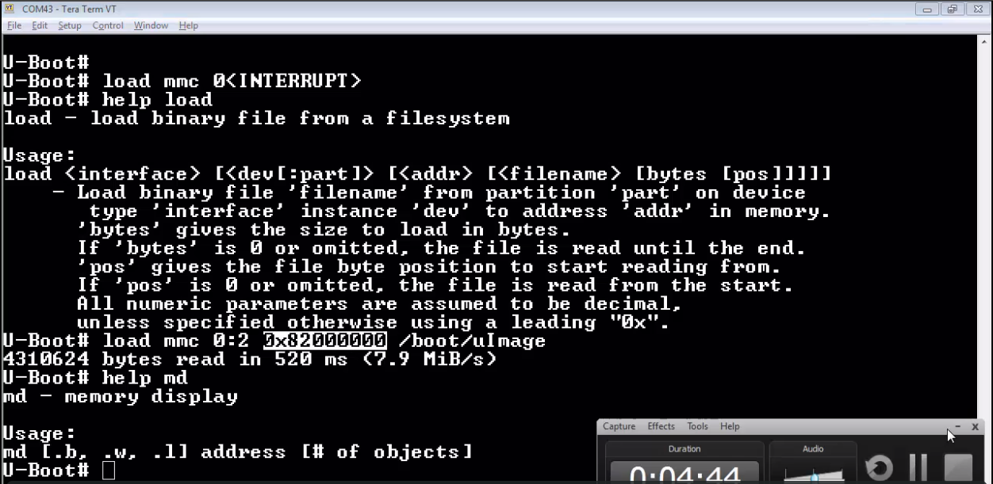
Here load mmc 0:2 --->:2 represents the second partition in SD card (1 is boot.2 ext4 ).
0x82000000 is ram address where to start it is ddr address .
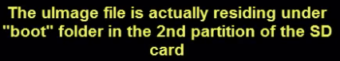
.

that is /boot/uImage.

Now use : md 0xx82000000 4
this is represents the 4-bit header infomation.

See in below fig.
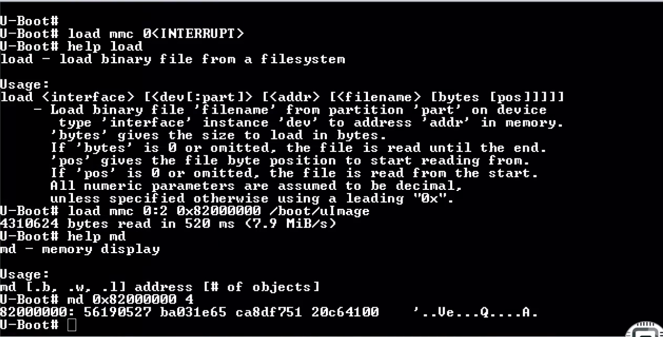
From above b2031e65 and other are in modified .we treat that as 651e03b2 like that model.

These four info represents below info.
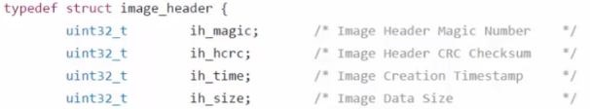

from above command generated info.

20C64100 info 41c620 convert this to decimal + 64=4310624 bytes it represents.



